Draft offer to Aristo
27th November 2025

- Licensor: Another Day Pharma Ltd
- Licensee: Aristo Pharma GmbH
Product
- BZ371A in any formulation, including its current formulation FAPP20 in any concentration
Indication
- Female Sexual Dysfunction, and specifically HSSD
Territory
- The EU, UK, Norway, Switzerland
License
- Exclusive license to develop and commercialise BZ371A for the named indication and territory.
- Ability to sublicense to affiliates within the Aristo group for the licensed territory and indication after informing ADP.
- Any sublicence, assignment or other transfer to third parties outside the Aristo group subject to prior ADP approval.
Governance
- Joint Drug Development Committee to be set up to coordinate and develop a strong brand strategy, development and regulatory activities (including any post launch development and/or regulatory activities) for the indication in the territory.
- Licensee agrees to share results of studies in its territory and grant customary rights of reference for the facilitation of development and regulatory approvals by ADP and its other licensees in other territories.
- The licensee agrees to use commercially reasonable efforts to develop the product for the named Indication in the Territory from the end of Phase IIa until at least the registration and regulatory approval of the product in every country in the Territory and following such regulatory approval to launch the product in each country in the Territory under a brand strategy approved by the JDDC. Such diligence will be subject to reversion rights in the event that licensee does not progress the product in the Indication in the Territory (and in the event of other termination events).
Transaction
The license within the scope and terms indicated above is subject to the following milestone payments:
- First payment: £6.6M Upon signing the final licensing agreement between Aristo and ADP
- Second payment: £5.7M upon starting Phase III in one country or more in the Territory
- Third payment: £6.3M on completion of Phase III in one country or more in the Territory
- Fourth payment: £6.4M on having obtained regulatory approval of the Product in at least one country of the Territory in the named Indication.
These payments will be invested into ADP via a Special Purpose Vehicle (SPV) managed by the founders of ADP as per the figure depicted here below:
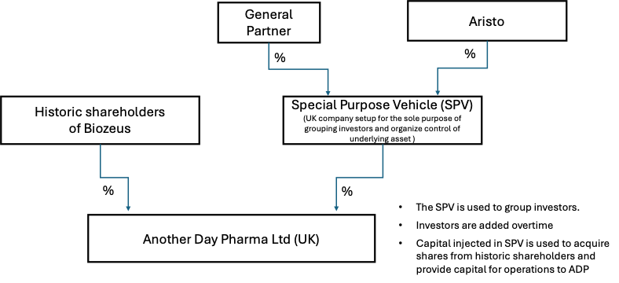
The table below shows an estimate of the share of ownership for Aristo resulted from these investments:
 | Estimated Aristo share of SPV | Estimated¹ Aristo Share of ADP
After 1st Payment | 25.8% | 16.1%
After 2nd Payment | 37.4% | 24.4%
After 3rd Payment | 44.5% | 32.8%
After 4th Payment | 48.8% | 38.7%

The SPV is managed by the GP which will control the majority of the shareholder voting rights, controlled by the founders which will collect a one-time 6% management fee (exclusive of VAT if applicable) for each and every investment in the SPV or any licensing payment into ADP.
From the moment a term sheet is signed on these terms Aristo will advance a non-refundable £1m deposit to ADP to cover transaction costs that will be offset, on completion, against the reminder of the 1st payment.
ADP will pursue the search of other licensees of the Product for other territories and/or indications, which will give right to licensing payments and royalties directly into ADP and or other investments into the SPV, if required.
Once the product is launched and commercialized these are the proposed royalty terms payable to ADP by Aristo.
- Royalty: 15% of Net Sales in the Territory, and the following
payments on reaching the following Sales Milestones:
- £5M on achieving €100M annual Net Sales
- £10M on achieving €250M annual Net Sales
- £15M on achieving €400M annual Net Sales
- £20M on achieving €600M annual Net Sales

The actual % depends on the step-up value of underlying acquisition of Biozeus finally agreed with its current shareholders. The current model is based on the agreed acquisition value and resulting dilution from required investments to fully develop the product. It is also subject to any dilution that would arise from other investors being issued shares from time to time (as noted below).

